BA 474 Team1 Final Project

Database Design and Implementation

March 8, 2022

Zhiyi Xue

Qi Xue

Lei Yang

Han Zhang

Table of Contents

**Executive summary** 3

**Introduction** 3

**Information Requirement** 3

**Implementation: Tables and Sample data** 5

**Business reports** 7

**Conclusion** 10

# **Executive summary**

First, we investigated the company's background and collected internal and external data in detail. In addition, our ideas are based on realistic considerations, and we actually start from the company's perspective, so that every decision can be as optimal as possible. In order to better normalize the data, we made an ERD diagram as an outline according to the actual situation of the company to prepare for the next step of data analysis. In step g, the data table is subdivided. The main table and the bridge table were both checked free of error and duplication. Thus, no matter if we want to delete, add new, or update data, existing data won't be affected. Eventually, three business reports were generated. Each of them covered the employee's relationship to the projects, the degree of project completion, and the employee's skills accordingly. Respectively. among them, by using SQL queries, we can quickly extract the desired information from complex tabular data. For details, please see step h.

# **Introduction**

Beavers technology solutions as an information technology company, its main business is to help some large companies or organizations analyze business data. Influenced by covid-19, more and more companies begin to implement remote working mode, which makes more and more businesses that need to be processed by BST. In order to help BST better solve the job assignment problem of internal employees and improve their work efficiency, we created ERD for the BST data we collected and obtained the relevant data diagram. In addition, we also designed three business reports, which are about employee projects, completed projects and employee skill. Based on these three reports, we make a corresponding summary of our overall analysis.

# **Information Requirement**

There are two main types of information that can help BTS, information that can help BTS solve problems and take advantage of opportunities. The first is the relevant company information; the knowledge of the company is divided into external and internal. This company's internal information mainly records employee information (professional, work efficiency, and residence). These can help managers better schedule employees and help arrange business trips or work faster. At the same time, it is also necessary to record the company's detailed sales records (time, location, price, buyer). This information can help BTS better understand how the company operates and BTS's largest customers and use this information to expand options, such as payment plans that optimize customer service. It can continue to maintain partnerships with these large customers in the process of expanding outward. At the same time, these sales records should also be associated with BTS's corporate team to minimize personnel transfers and unnecessary new arrangements. Both pieces of information can help companies make better control and decision-making. Then you should also know about the project separately. First, you need relevant meeting minutes to understand the preparations before the project. The second is information about the project's progress, such as estimated completion time.

Finally, you need to understand the summary information after the project is completed, such as comparing budget and actual cost. A report from outside the company mentioned in the article indicated a problem due to the excessive number of employees, in cooperation with BTS's IT, resulting in a reduction in the efficiency of the use of Google spreadsheets. The company can find more information on Office Tools. New tools simplify the process and make it easier to use alternatives. This information can improve the work efficiency of the BTS company.

f. Conceptual design: ERD and Business rules

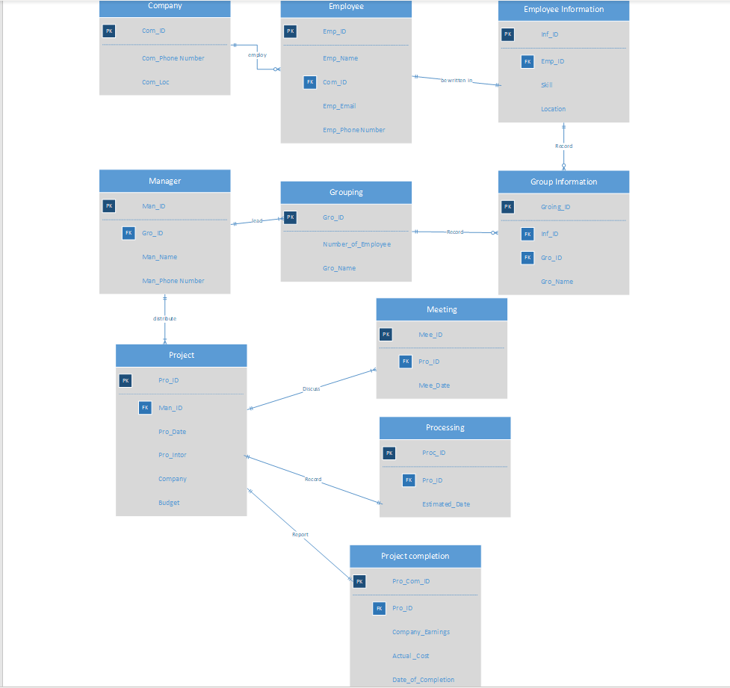

In this ERD diagram, the business rules of the company are expressed. First, the company has branches in various parts of Oregon, so the first entity is the company and the primary key is the company ID. It is connected to the employee entity. The relationship is 1:M, that is to say, a company can have many employees or not, but an employee can only belong to one company. In the employee entity, the primary key is the employee ID and the foreign key is the company ID. This entity primarily expresses the employee's personal information (name, contact details, etc.). It has a 1:1 relationship with employee information. In the employee information entity, the primary key is the information ID, and the foreign key is the employee ID. In this entity, additional information of the employee, such as skills and address, is mainly displayed. This is to facilitate grouping. The next entity is the bridging entity, because the relationship between the employee information entity and the grouping entity is M:N, so create a bridging entity so that their relationship becomes 1:M. In this entity, the primary key is Groing_ID, and the foreign keys are Inf_ID and Gro_ID. In the group entity, the basic information of the group is mainly displayed to facilitate future work more efficiently. Also connected to the manager entity. The relationship is 1:M, that is, a team can only be led by one manager, but a manager can lead multiple teams. In the manager's entity, the primary key is the manager ID and the foreign key is the Gro_ID. It also contains the manager's personal information. In the seventh entity "Project", it has a 1:M relationship with the "Manager" entity, that is, a project can only correspond to one manager, but a manager can be responsible for multiple projects. In the project entity, the primary key is the project ID, and the foreign key is the manager ID, which contains all the information about the project, such as project date, description, company, budget. At the same time it is connected to three other entities. 1. A "meeting" entity, which is a discussion that takes place after a project is released to allow the project to proceed more quickly. The primary key is Mee_ID and the foreign key is Pro_ID. The relationship between these two times is 1:M. 2. The "Processing" entity that describes information during the course of the project, such as the estimated time of completion. The relationship between the two is 1:1. In this entity, the primary key is Proc_ID and the foreign key is Pro_ID. 3. The "Project Completion" entity is a summary report after the project is completed, describing the actual completion time and cost, and the profit created. It has a one-to-one relationship with the project entity. The primary key is Pro_Com_ID and the foreign key is Pro_ID.

# **Implementation: Tables and Sample data**

After designing the library according to the ERD, the following data diagram is obtained, as shown in Figure 2.

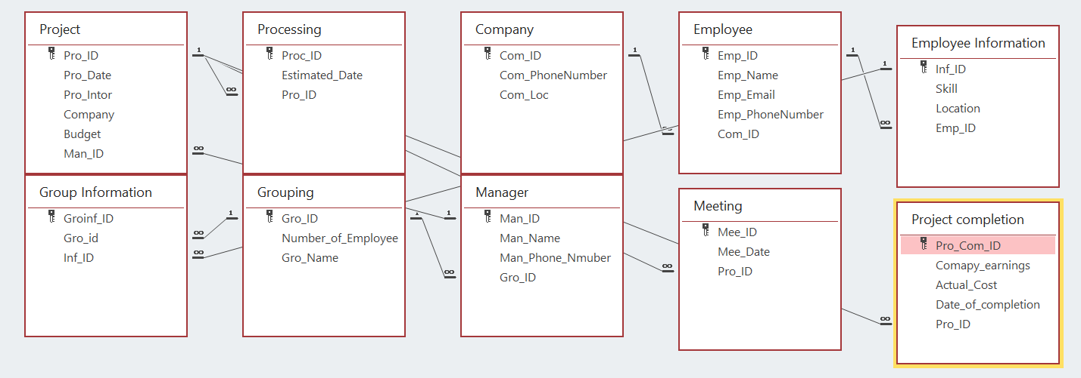

Figure 2

In this database, the two most important tables are the Employee Information (Figure 3) and Project (Figure 4) tables.

In the Employee Information table, the skill information and location information mastered by the employee are displayed, as well as the id of the employee information and the id of the employee, indicating that there is a connection between the table and the employee table, and the id of the employee can be quickly matched with the table Employee data to communicate. Through the Employee Information table, when the docking staff receives a new project, the manager can quickly find the technology required for the project in the table, and then select the employee ID closest to the destination, send the employee ID to the manager and Forming corresponding teams increases the efficiency of doing business without creating confusion in employee selection.

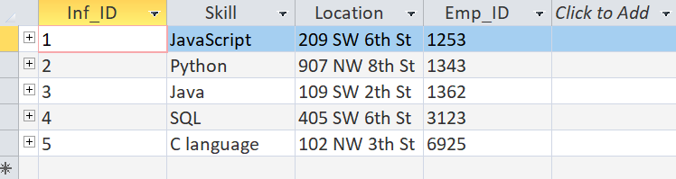

Figure 3

In the Project table, the id number of the project, the start date of the project, the description of the project, the corresponding company, the budget of the project and the ID number of the manager are displayed. This table is connected to the manager table, so you can clearly see the person-in-charge id corresponding to each project id. With the project start date, managers can check on projects that start very early to prevent project delays. In addition, the description of the project can help decision makers find the corresponding team to handle the project, so as not to be unable to match the appropriate team. The name of the company in the table is also very important. Managers can respond in time by checking the status of these companies. For example, when the news of the company is about to go bankrupt, the manager needs to contact the company in time to discuss the continued implementation of the project. feasibility to avoid losses. And, by knowing the budget of each project, managers can also infer the scale of the project and start planning accordingly. When the project changes, the decision makers can immediately find the corresponding manager according to the project company, so that the corresponding team can receive the information quickly to prevent information lag, which can not only reduce losses but also improve efficiency.

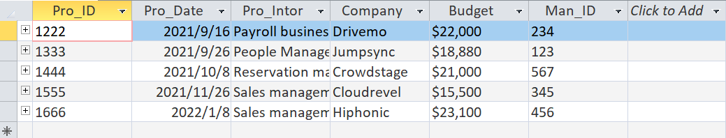

Figure 4

# **Business reports**

|  |  |  |  |  |  |
| --- | --- | --- | --- | --- | --- |
| **Employee project summary** | | | | | |
| For 1/9/2021 thru 1/31/2022 | | | | | |
| Emp_Name | Number  Of projects | Total  earning | Average  Project Amount | Total cost | Total Project profit |
| Brittney Bertrand | 1 | 67800 | 67800 | 30000 | 37800 |
| Carson Hull | 1 | 84756 | 84756 | 43957 | 40799 |
| Erika Smith | 1 | 65481 | 65481 | 55901 | 9580 |
| Joseph Defilippis | 1 | 25400 | 25400 | 21000 | 4400 |
| Jovana Subasic | 1 | 95872 | 95872 | 59240 | 36632 |

Short narrative:

The report obtains the employee projects from September 2021 to January 2022. The report lists the names of employees, the number of employee projects, the total income of the projects involved, the average income of each project, the total cost of the project and the overall profit of the project.

SQL queries:

SELECT Employee.Emp_Name, COUNT( Project.Pro_ID) AS number_of_projects ,

SUM([Project completion].Comapy_earnings) AS total_enrning,

AVG([Project completion].Comapy_earnings) AS Average_Project_amount,

sum([Project completion].Actual_Cost) as total_cost

FROM (((Grouping INNER JOIN Manager ON Grouping.Gro_ID = Manager.Gro_ID)

INNER JOIN ((Employee INNER JOIN [Employee Information]

ON Employee.Emp_ID = [Employee Information].Emp_ID)

INNER JOIN [Group Information]

ON [Employee Information].Inf_ID = [Group Information].Inf_ID)

ON Grouping.Gro_ID = [Group Information].Gro_ID)

INNER JOIN Project

ON Manager.Man_ID = Project.Man_ID)

INNER JOIN [Project completion]

ON Project.Pro_ID = [Project completion].Pro_ID

WHERE [Project completion].Date_of_completion >=#2022/01/01#

and [Project completion].Date_of_completion <=#2022/03/31#

GROUP BY Employee.Emp_Name;

|  |  |  |  |  |  |  |
| --- | --- | --- | --- | --- | --- | --- |
| **Completed project information sheet** | | | | | |  |
| Pro_ID | Pro_Intor | Budget | Man_Name | Actual_Cost | Comapy_earnings | Days |
| 1222 | Payroll business system | 22000 | Megan Fischer | 21000 | 25400 | 154 |
| 1333 | People Management System | 18880 | Alexis Bell | 30000 | 67800 | 161 |
| 1444 | Reservation management system | 21000 | Will Jensen | 59240 | 95872 | 115 |
| 1555 | Sales management system | 15500 | Nicole Gelow | 43957 | 84756 | 95 |
| 1666 | Sales management system | 23100 | Sophia Harman | 55901 | 65481 | 74 |

Short narrative:

The report obtains the information of all currently completed projects. The report lists the number of completed projects, project name, project budget, project manager of the project, total expenses incurred by the project, actual collection amount of the project, construction days of the project, and finally the actual profit of the project.

SQL queries:

SELECT Project.Pro_ID,

Project.Pro_Intor,

Project.Budget,

Manager.Man_Name,

[Project completion].Actual_Cost,

[Project completion].Comapy_earnings,

DATEDIFF("D",Project.Pro_Date,[Project completion].Date_of_completion) AS Days,

[Project completion].Comapy_earnings-[Project completion].Comapy_earnings as actual_profit

FROM ((Manager

INNER JOIN Project ON Manager.Man_ID = Project.Man_ID)

INNER JOIN Meeting ON Project.Pro_ID = Meeting.Pro_ID)

INNER JOIN [Project completion] ON Project.Pro_ID = [Project completion].Pro_ID;

|  |  |  |  |  |
| --- | --- | --- | --- | --- |
|  | **Employee skill information form of the company's project** | | | |
| Com_ID | Com_Loc | Emp_number | skill_number | Pro_Number |
| 1 | 1060 Valley River Way | 1 | 1 | 1 |
| 2 | 1555 NW Monroe Ave | 1 | 1 | 1 |
| 3 | 450 SW 3rd St | 1 | 1 | 1 |
| 4 | 701 SW 7th St | 1 | 1 | 1 |
| 5 | 875 SW Bay Blvd | 1 | 1 | 1 |

Short narrative:

The report lists the skill information of project employees of each company, which can intuitively see how many employees there are in each company, what technologies (skills) the company has, and how many projects it has undertaken in total. This facilitates the bidding team to intuitively grasp the comprehensive strength of each company.

SQL queries:

SELECT Company.Com_Loc,

Count(Employee.Emp_ID) AS Emp_number,

Count([Employee Information].Skill) AS skill_number,

Count(Project.Pro_ID) AS Pro_Number

FROM ((Grouping

INNER JOIN (((Company

INNER JOIN Employee ON Company.Com_ID = Employee.Com_ID)

INNER JOIN [Employee Information] ON Employee.Emp_ID = [Employee Information].Emp_ID)

INNER JOIN [Group Information] ON [Employee Information].Inf_ID = [Group Information].Inf_ID)

ON Grouping.Gro_ID = [Group Information].Gro_ID)

INNER JOIN Manager ON Grouping.Gro_ID = Manager.Gro_ID)

INNER JOIN Project ON Manager.Man_ID = Project.Man_ID

GROUP BY Company.Com_Loc;

# **Conclusion**

Our team collected data about BTS's employees, projects and companies, and created an ERD and database. We found that in order to quickly allocate projects to more matching employees, quickly check the current status of the company and monitor the loss degree of projects made by the company, they can be reflected in the tables in the database. BTS can better manage the completion efficiency of employees and projects according to these contents, so as to improve the performance of the company.